Py City School District Analysis

Mankwe Ndosi
U of M Data Visualization and Analysis Bootcamp
Nick Sneed - Instructor
November, 2022
Abstract:

An analysis of the PyCity School District (PCSD) finds that schools with fewer students and lower budgets per student have been most successful at helping their students achieve on Math and Reading standardized tests and passing these courses.. In PCSD the top five schools in Average Reading and Math scores are all smaller, lower budget Charter Schools. In PCSC all of the Public Schools are larger, relatively higher budget schools. There are no small Public Schools, or large Charter schools so we are unable to tell if the type of school is influential as distinct from their size and budgets. Accordingly, looking for ways to develop a smaller school structure is recommended as a strategy to support student success.

Introduction

Py City School District embarked on this analysis in order to assist the mayor and school district to make strategic decisions about future school budgets and priorities. As a first step in the analysis - I looked at district wide standardized test results for all students in the 15 PyCity Schools in the District. I aggregated the data to look at clear trends in school performance.

I did both District Level and School level analysis including: school size (number of students), annual budgets, average spending per student, average math and reading test scores, and percentage of students passing math, reading, and overall (both math and reading) test scores. I looked for clear trends in test scores and percentages of students passing foundational skills in relationship with school size, spending per student, and school type.

Methodology

I worked with the computer language Python and the Python libraries Pandas and Numpy for the analysis of the data provided in Student data and School data files supplied by PCSD.

Results and Discussion

PCSD has 15 schools, (7 District and 8 Charter) with a total budget of $24,649,428. PCSD serves 39,170 students. 75% of students passed Math, 86% of students passed Reading, and 65% of students passed both Math and Reading. Average Math and Reading test scores were 79 and 82 of 100 respectively.
At the school level the top five high performing schools were all Charter schools with more than 90% of students passing both Math and Reading and with average test scores 6 to 7 points higher in Math and Reading than the lowest performing schools. The lowest performing schools were all District Public Schools with 53 or 54% of students passing both Math and Reading. Average test scores in these lowest performing schools were below the District averages with Reading scores having the most pronounced difference at 5 points lower than the District Average.
Both size and spending per student had a negative correlation with Average test scores and Percentage of students passing these tests.

Results by School Spending Per Student
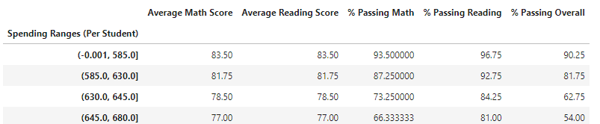

Results by School Size
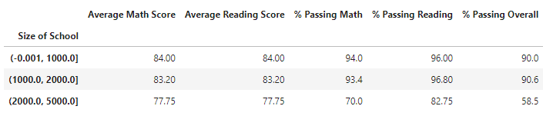
The tables above give the most important data to my conclusion that the smaller schools with lower spending per student have been more successful in preparing their students for the standardized tests in Reading and Math.

These results were highly visible in looking at results by type of school - particularly looking at the percentage of students passing Math and the percentage of students passing both Math and Reading (Passing Overall).

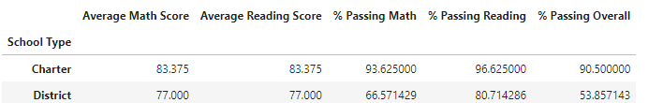

However, as all the District Public Schools were the larger schools with higher spending per student, and all the Charter Schools are smaller with lower spending per student it is unclear whether the type of school alone has an impact on student test prep.
This analysis was strictly on standardized test performance within PCSD. Additional measures of student performance, social experience, classwork, cultural and relational will be necessary to analyze the success of students in Public and Charter schools in the district with a more thorough perspective. But from the standpoint of standardized tests alone, smaller schools with lower budgets, in this case Charter schools have more successfully prepared students for test success.

Conclusions

In Conclusion, it is clear that the Charter schools in PCSD have been stronger in preparing students for Math and Reading standardized tests. Smaller schools, with lower spending per student, had the highest average scores in Math and Reading tests and higher percentages of students passing these tests than the larger Public Schools with higher spending per student.

Appendices
- Code and Tables: https://github.com/mndosi/Pandas_Challenge

